

***Holland MI Ride of Silence:***

From the Holland Civic Center parking lot. Arrive by 6:30 PM for announcements. Route is 7.5 miles.

(Rain Date: Sat. May 19th at 10 AM)

**Helmets Required, Lights Recommended**

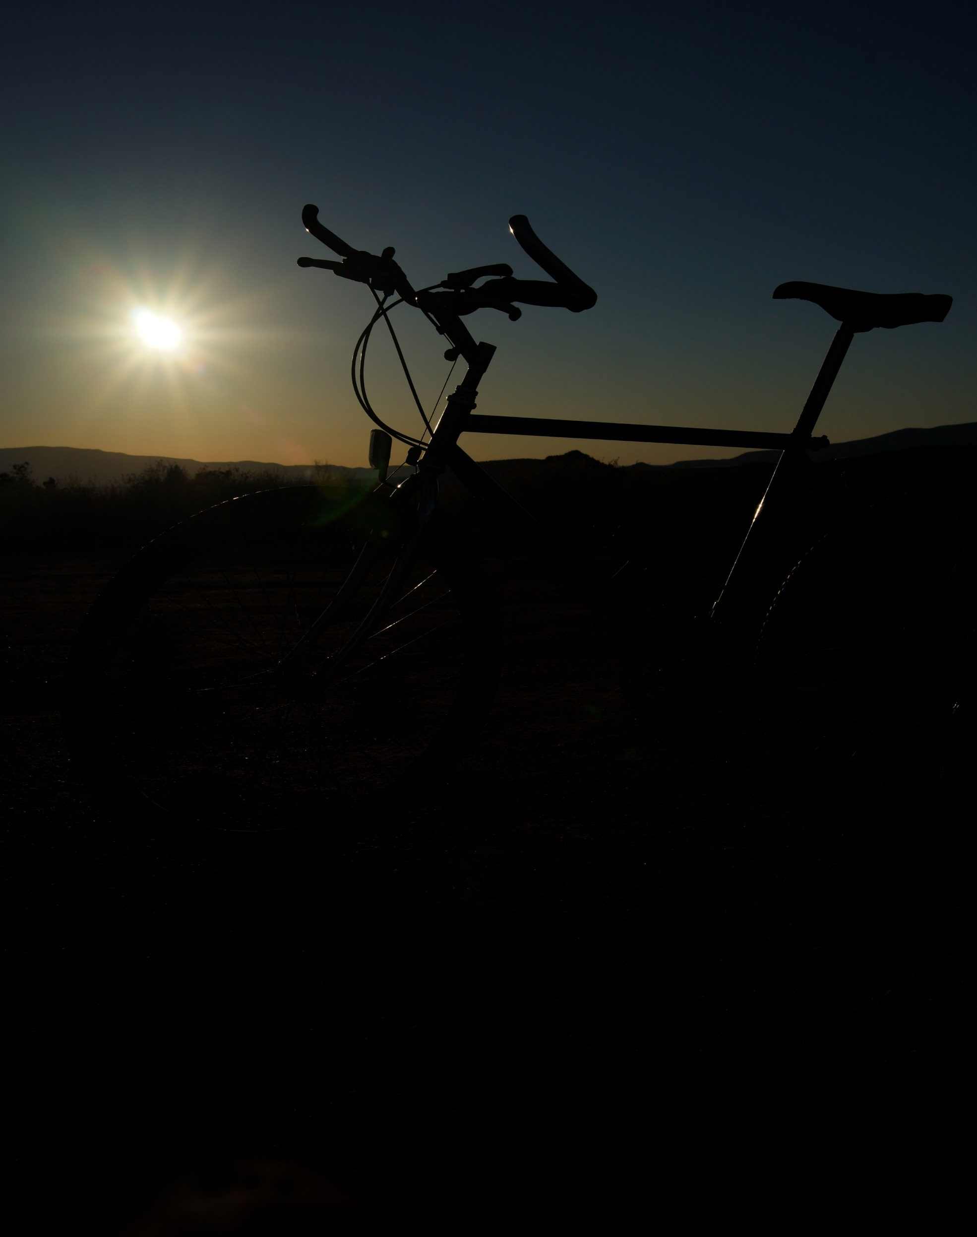

***“Remember Their Names”***

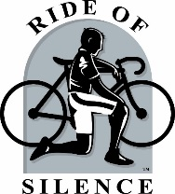

**Contact:** Mark Hagar

mark.hagar@rideofsilence.org

[**www.rideofsilence.org**](http://www.rideofsilence.org)

***(please be kind & recycle this poster)***

**Wed. May 16th, 7:00 PM**

**(**hundreds of locations worldwide**)**

**Short Slow paced (12 mph max) FREE Ride raising Awareness of Cyclists Rights to Public Roadways while Honoring Riders Injured or Killed.**

**2018 Worldwide**

**Ride of Silence**